Recruitment
Binder
2018-2019

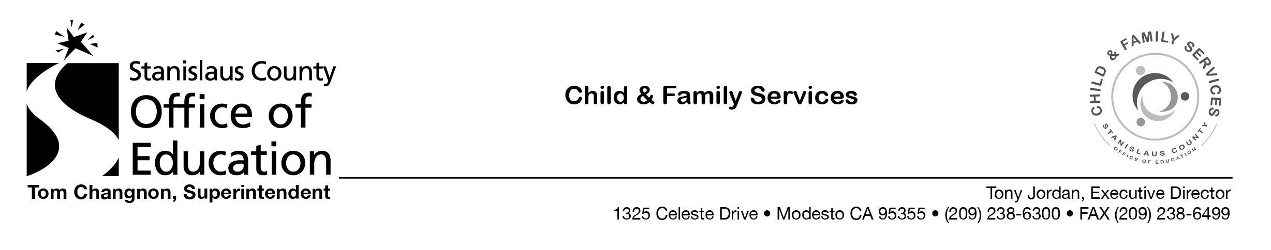

RECRUITMENT BINDER TABLE OF CONTENTS

Head Start/Early Head Start Eligibility, Recruitment, Selection, Enrollment and Attendance Policy

Community Outreach Plan

Community Agency Flyers

Monthly Tabs:
- Maintain the Community Agency Contact Record (Form CF/S-7) for each month

- Eligibility Waiting List pulled within the first 5 business days of each month with notes regarding status of application

- Recruitment Tab List pulled within the first 5 business days of each month with notes regarding status of application

