To: SCOE GO Team
From: Jewelee Hotchkiss
Date: December 18, 2017
Child Information Sheet
- The Mental Health Questions on the Child information sheet need to be entered into COPA using COPA Procedure DMH06. This step may have been missed with the latest application procedure change.
- Ensure that FSWs enter this information no later than January 19, 2017
Program Information Report
- Your review of the PIR is due to me by Friday, January 19th
- Utilize the PIR Tip Sheet that Chris will provide
- Send me a note that you have completed your thorough review of the PIR along with a bulleted list of any changes I need to make to the HR section of COPA
Parent Café Training
- Please see the attached schedule of Parent Café facilitator trainings. Please have FSWs and MT attend if you’re at a pilot site and haven’t been trained
Winter Break Meals
- Please find the menus for the next few weeks attached.
Implementation Items Chart
- Attached is a document developed by the Grantee to include the items implemented by SCOE Head Start to support comprehensive services.
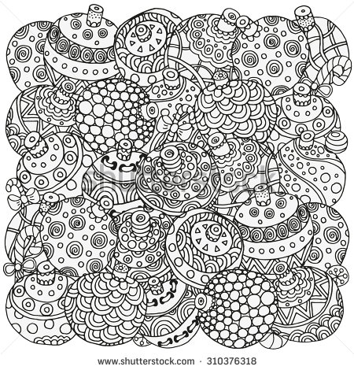
Winter Break Coverage
- December 28 & 29th Evelyn and Guille are working
- January 3-5 Michelle, Evelyn, Guille, Norma, & Shawnda are working
- Chris and Jewelee will be off both weeks. Call my cell if you have an emergency.
Upcoming Dates
- Jewelee and Lucy will be in San Diego the week of 1-8-18 for the PITC Conference
- Our Program Monitoring Event is the week of January 22nd. I will send out more information with the January 8th memo.

