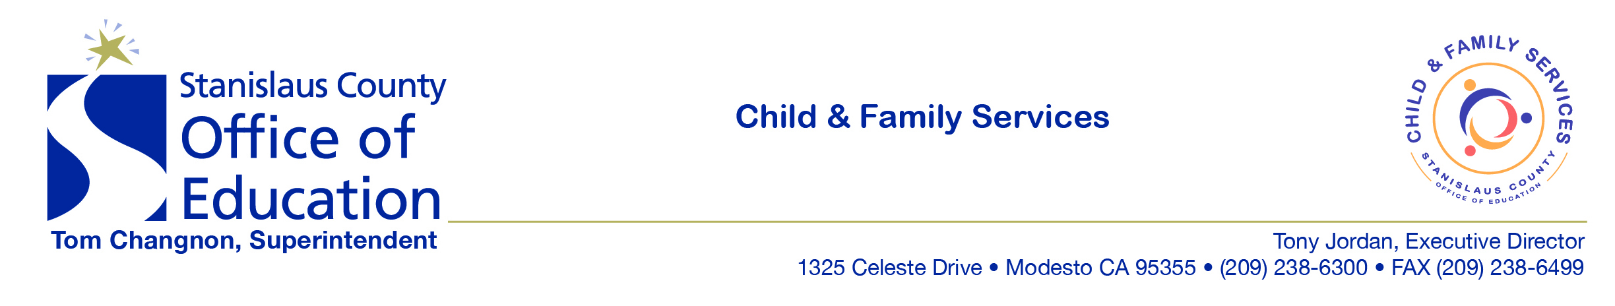

To: SCOE GO Team
From: Jewelee Hotchkiss
Date: July 23, 2018
And we’re back!
- We’ll be starting up the weekly memos again. I know it’s a little early for Extended Day but a lot of information was accumulating and needed to go out. I hope your summer has offered you some relaxation and fun! If you are working throughout summer like me, I want to thank you for your continued service to our families. You make all the difference!
We Rock Updates
- Please see the attachment for important updates to www.findchildcarestanislaus.org/werock
- Share this information will all staff!!
Handbooks/Application Packets
- 2018-2019 Parent Handbooks & Application packets have been uploaded on www.findchildcarestanislaus.org under “SCOE CFS Enrollment” (note: this is outside “WeRock” so it is accessible to families)
Personal Activity Report
- July is a PAR month, please ensure that your multi-funded staff (and yourself) submit your PAR on time
Personally Identifiable Information
- As a reminder, we cannot email or use electronic fax to transmit Personally Identifiable Information (such as both child’s name and birthday. We cannot receive this information from parents by email/electronic fax either. When emailing about children/families, use COPA ID #s.
- We are working on a Laserfishe solution to transmit documents between sites and the FES.
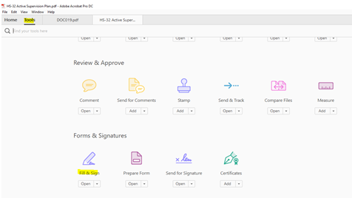
Budget
- I wanted to alert you that as we wind down the fiscal year, we have nearly maximized our budgets. For this reason, please do not make any purchases (such as cash buyouts) that are not absolutely necessary.
Forms
- You may notice that the 2018 forms on the CFS Webpage don’t have usable/type-able versions. This is because with the new version of Adobe you can fill out any form by doing a Save As to the document. You then open your saved document, Click on Tools, Click on Fill & Sign
Binder Updates
- Don’t forget to update all your binders for 18-19. The binder cover and contents can be found on www.findchildcarestanislaus.org/werock
- Education staff—Remember to update children’s DRDP binders with 18-19 program year information and to begin individualization on Activity Plans the first month of enrollment.
Social Emotional Strategies
- I have attached two documents related to implementation of Social Emotional Strategies. Please review
- Please determine how to infuse our program wide expectations “We Are Kind. We Are Safe. We Are Helpful” into all aspects of our program. How can those be infused into staff meetings/positive feedback efforts?
Home Visit Safety Kits
- In line with our Home Visit Safety Procedure (attached), each site will be receiving two Home Visit Safety Kits. They are bright orange backpacks. Please make sure staff is aware of their location and contents. We did not receive jumper cables for every bag yet so some will arrive to you incomplete.
SCOE GO Directory
- Our Directory has been updated. Please see the attachment and alert our admin team of any needed changes

Reminders:

Health and Safety Screener
- Please ensure you are using the new versions of all monitoring tools. They can be found at https://www.stancoe.org/basic-page/cfs-monitoring-tools . Please pay special attention to the Guidance documents when conducting monitoring. I have attached the Health and Safety Screener Document and Guidance for your use.
Standing Water
- Do not leave filled water tables unattended. Dump them out before you transition inside. Standing water poses a drowning risk, especially when there is not adult supervision.
Cell Phone
- Staff and families are prohibited from cell phone use while supervising children. Staff has been observed utilizing phones while responsible to supervise children. If staff must attend to an emergency, they need to communicate and step off the floor
Application Checklists
- Please ensure staff does not use the attached half sheet entitled “Head Start Eligibility Criteria”
- Instead, use the attached Application Requirements Checklists (note one is labeled for Extended Day an d the other is for full day

“There are only two ways to live your life. One is as though nothing is a miracle. The other is as though everything is a miracle.” — Albert Einstein

