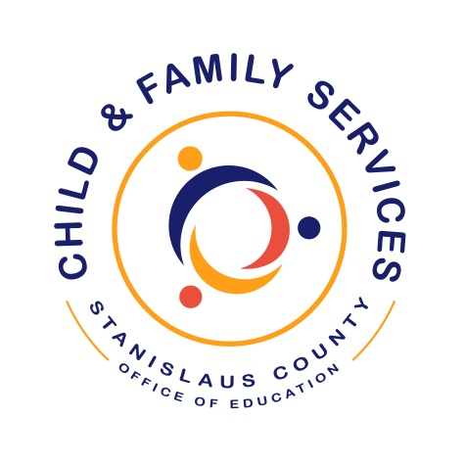

Monitoring Binder
2018-2019

Binder(s): 1 of 1
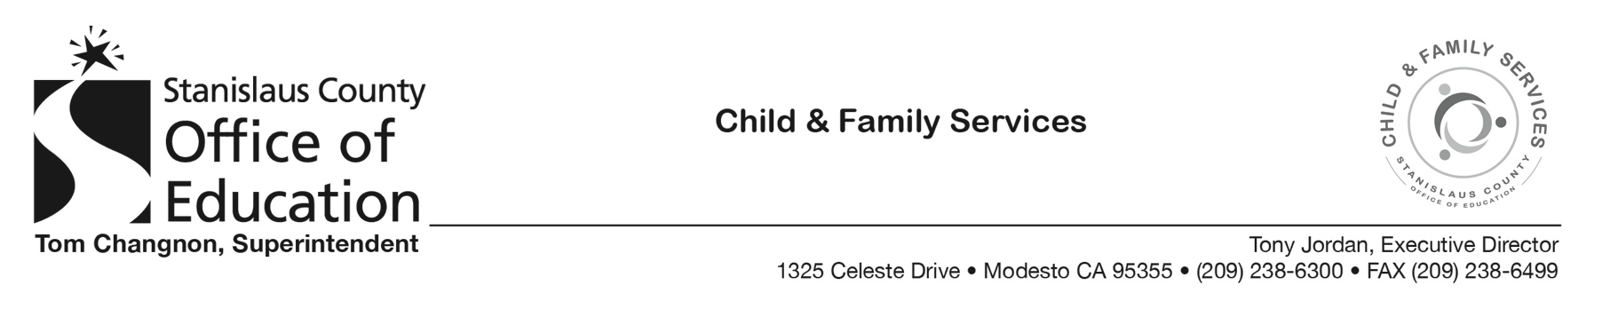

MONITORING BINDER

- Current Year Monitoring Plan
- Health & Safety
- Unannounced Supervision
- ERSEA
- Family & Community Engagement
- Education, Disabilities and Mental Health
  - TPOT
  - CLASS
  - Fidelity to Curriculum (centers)
  - Growing Great Kids Competency (home based)
- Program Management & Quality Improvement
  - Program Governance
  - Human Resources
- Fiscal, Facilities and Transportation

